Use-Case-Model Survey for CMP Use Case

Issue 1.0
Revision History
Date | Issue | Description | Author
01/Aug/09 | 1.0 | First Issue | Thomas Yap

Table of Contents
1. Introduction 5
2. Actors 5
2.1 Portal Admin 5
2.2 User 5
2.3 User Admin 5
3. Use Cases 5
3.1 Add Customer 5
3.2 Add DAP 6
3.3 Add FAP 6
3.4 Add Lesson 6
3.5 Add MCQ 6
3.6 Add Question 6
3.7 Add Role 6
3.8 Add Survey 6
3.9 Add User 6
3.10 Add User Admin 6
3.11 Delete Customer 6
3.12 Delete DAP 6
3.13 Delete FAP 6
3.14 Delete Lesson 6
3.15 Delete MCQ 6
3.16 Delete Question 6
3.17 Delete Role 6
3.18 Delete Survey 6
3.19 Delete User 7
3.20 Delete User Admin 7
3.21 Display Customer Info 7
3.22 Display Customer List 7
3.23 Display DAP Info 7
3.24 Display DAP List 7
3.25 Display Exam Result 7
3.26 Display Excercise Result 7
3.27 Display FAP Info 7
3.28 Display FAP List 7
3.29 Display Lesson Content 7
3.30 Display Lesson Info 7
3.31 Display Lesson List 7
3.32 Display MCQ Info 7
3.33 Display MCQ List 7
3.34 Display Question Info 7
3.35 Display Question List 7
3.36 Display Report List 8
3.37 Display Role Info 8
3.38 Display Role List 8
3.39 Display Survey Info 8
3.40 Display Survey List 8
3.41 Display Survey Result 8
3.42 Display User Admin Info 8
3.43 Display User Admin List 8
3.44 Display User Info 8
3.45 Display User List 8
3.46 Display User Menus 8
3.47 Generate Lesson List 8
3.48 Generate Questions 8
3.49 Maintain Customer 8
3.50 Maintain DAP 8
3.51 Maintain FAP 8
3.52 Maintain Lesson 8
3.53 Maintain MCQ 8
3.54 Maintain Question 9
3.55 Maintain Role 9
3.56 Maintain Survey 9
3.57 Maintain User 9
3.58 Maintain User Admin 9
3.59 Process Survey Result 9
3.60 Retrieve DAP Info 9
3.61 Retrieve FAP Info 9
3.62 Retrieve Role Info 9
3.63 Take Exam 9
3.64 Take Exercise 9
3.65 Take Lesson 9
3.66 Take Survey 9
3.67 Update Customer 9
3.68 Update DAP 9
3.69 Update Exam Progress 9
3.70 Update FAP 9
3.71 Update Lesson 10
3.72 Update Lesson Progress 10
3.73 Update MCQ 10
3.74 Update Question 10
3.75 Update Role 10
3.76 Update Survey 10
3.77 Update User 10
3.78 Update User Admin 10
3.79 User Login 10
3.80 User Logout 10
3.81 View Report 10
4. Views 11

Use-Case-Model Survey for CMP Use Case
«This report assumes that the model is structured according to the Rational Unified Process structure that you can see in the Rational Rose 2000 framework, named “Rational Unified Process”. This is also described in the tool mentor for this report inside the Rational Unified Process»
«Text in green indicates manually maintained text, captured in the document itself rather than in any tool.»

Introduction
The Index Info Systems Pte Ltd (IIS) requires the development and deployment of a web learning portal for their business strategy partners and customers to fulfill their staff learning and training requirements. Through this system, IIS can create unlimited and diverse learning packages, including the learning content, MCQ (Multiple Choice Question), Survey, Certificate, User Control etc. IIS can then sell the packages to their business customers, and support them with their staff learning process. The user requirements are defined in "User Requirements Specification" of Content Management Portal. The system is to be developed using object-oriented techniques and Microsoft C# and .NET platform.
The highest level of object oriented analysis involves describing the requirements in terms of Use Case. The aim of the Use Case Model is to provide an overview of these use cases and their users.

The main users of the Content Management Portal are the:
1. The User who select the course, attend the course, take the exercise or exam, take the survey and print out certificate.
2. The User Admin who maintain users profiles and user-course profiles.
3. The Portal Admin who maintains the students, course materials, generates reports and system administration.
The sequence of the use cases which are typically performed in the system are described in the following subsections.

Actors

Portal Admin
Documentation: The service provider IIS, who will maintain company membership, learning modules, questionnaire, surveys, print reports and members. And will also manage the system access control rights and be responsible for the system maintenance.

User
Documentation: Who will obtain the necessary information for their training needs. The user will be able to browse the assigned learning modules, take exercise or examination, monitor their own learning progress, print report, and exam certification.

User Admin
Documentation: Training Management Staff in an organization who subscribed the services as a member. The member will be using the system to enroll trainees, assign modules to the trainees, manage the contents in the module and post the publications in the forum via the web portal.

Use Cases

Add Customer
Documentation: This is the use case for adding new customer.

Add DAP
Documentation: This use case add a new Data Access Profile that maintain access rights for user on e-learning materials.

Add FAP
Documentation: This use case add a new Functional Access Profile that maintain access rights what an user can or cannot do. This includes read only / write access rights.

Add Lesson
Documentation: This use case is to add / upload content to the Content Management System.

Add MCQ
Documentation: This use case is to add/create a new Multiple Choice Questions for examination or exercise.

Add Question
Documentation: This use case is to add/create new questions for examination or exercise to the questions pool.

Add Role
Documentation: This use case is to add the role to an user.

Add Survey
Documentation: This use case is to add a new survey page to the survey pool.

Add User
Documentation: This use case is to add a new user that can access the CMP system.

Add User Admin
Documentation: This use case is to add a new User Admin of a company that can access the CMP system.

Delete Customer
Documentation: This is the use case for removing a customer. Customer is refers to company or partner organisation. The customer could be no longer subscribe to the e-learning portal services or no longer existing.

Delete DAP
Documentation: This use case remove a Data Access Profile that maintain access rights for user on e-learning materials.

Delete FAP
Documentation: This use case remove a Functional Access Profile that maintain access rights what an user can or cannot do. This includes read only / write access rights.

Delete Lesson
Documentation: This use case is to remove content from the Content Management System.

Delete MCQ
Documentation: This use case is to remove a Multiple Choice Questions for examination or exercise.

Delete Question
Documentation: This use case is to delete/remove questions for examination or exercise from the questions pool.

Delete Role
Documentation: This use case is to remove the role to an user.

Delete Survey
Documentation: This use case is to remove a survey page from the survey pool.

Delete User
Documentation: This use case is to remove an user from the system.

Delete User Admin
Documentation: This use case is to remove an User Admin of a company that can access the CMP system.

Display Customer Info
Documentation: This is the use case for searching and displaying the customer detail info on screen .

Display Customer List
Documentation: This is the use case for searching and displaying the customer listing listing on screen prior to do searching for customer details.

Display DAP Info
Documentation: This use case display any Data Access Profile that maintain access rights for user on e-learning materials.

Display DAP List
Documentation: This use case display and list the main title of a Data Access Profile that maintain access rights for user on e-learning materials.

Display Exam Result
Documentation: This use case is to allow an user to display the exam result.

Display Excercise Result
Documentation: This use case is to allow an user to display the exexrcise result.

Display FAP Info
Documentation: This use case displays a Functional Access Profile that maintain access rights what an user can or cannot do. This includes read only / write access rights.

Display FAP List
Documentation: This use case display and list a Functional Access Profile that maintain access rights what an user can or cannot do. This includes read only / write access rights.

Display Lesson Content
Documentation: This use case is to display the e-learning content on screen based on user selection/subscription.

Display Lesson Info
Documentation: This use case is to display content of the Content Management System.

Display Lesson List
Documentation: This use case is to display and list the content of the Content Management System.

Display MCQ Info
Documentation: This use case is to display the Multiple Choice Questions for examination or exercise.

Display MCQ List
Documentation: This use case is to display a list of Multiple Choice Questions for examination or exercise.

Display Question Info
Documentation: This use case is to display the detail questions info for examination or exercise from the questions pool.

Display Question List
Documentation: This use case is to display a list of questions for examination or exercise from the questions pool.

Display Report List
Documentation: This use case is to allow an user to list all the report he/she entitled to.

Display Role Info
Documentation: This use case is to display the detail of the role to an user.

Display Role List
Documentation: This use case is to display the list of user having a particular role.

Display Survey Info
Documentation: This use case is to display the survey details page.

Display Survey List
Documentation: This use case is to display list the survey page from the survey pool.

Display Survey Result
Documentation: This use case is to display the collected survey result.

Display User Admin Info
Documentation: This use case is to display the detail info of an User Admin of a company that can access the CMP system.

Display User Admin List
Documentation: This use case is to display the list of User Admin that can access the CMP system.

Display User Info
Documentation: This use case is to display the user details.

Display User List
Documentation: This use case is to display a list of user that can access the CMP system.

Display User Menus
Documentation: This use case display a menu to allow an user to input ID and password.

Generate Lesson List
Documentation: This use case is to generate the list of lessons subscribed.

Generate Questions
Documentation: This use case is to allow the CMP ssytem to generate the exam questions real time.

Maintain Customer
Documentation: This use case is to add, update, remove or list a customer. Customer is refers to company or partner organisation.

Maintain DAP
Documentation: This use case allows the Portal Administrator to maintain Data Access Profiles.It includes creation, modification and deletion as well as view the information for the profiles.

Maintain FAP
Documentation: This use case allows the Portal Administrator to maintain Function Access Profiles. It includes creation, modification and deletion as well as view the information for the profiles.

Maintain Lesson
Documentation: This use case is to add, update, remove or display the content of this Content Management System.

Maintain MCQ
Documentation: This use case is to add, update, remove and list the Multiple Choice Questions for examination or exercise.

Maintain Question
Documentation: This use case is to add, update, remove or list the questions for examination or exercise to/from the questions pool.

Maintain Role
Documentation: This use case allows the Portal Administrator to maintain roles. It includes creation, modification and deletion as well as view the information for the roles. Each role will be tied up with list of available functions (FAP) in the system. Whenever the content is uploaded into the system, respective data access profiles will be created and it will be tied up to the role.

Maintain Survey
Documentation: This use case is to add, update, remove and list the survey page to/from the survey pool.

Maintain User
Documentation: This use case is to add, update, remove and list the user that can access the CMP system.

Maintain User Admin
Documentation: This use case is to add, update, remove and list the User Admin of a company that can access the CMP system.

Process Survey Result
Documentation: This use case is to progress and compile the survey data and generate a report.

Retrieve DAP Info
Documentation: This use case is to retrieve the user privilege.

Retrieve FAP Info
Documentation: This use case is retrieve the user access rights.

Retrieve Role Info
Documentation: This use case is to retrieve the user's role.

Take Exam
Documentation: This use case is to allow an user to access the CMP to take an exam.

Take Exercise
Documentation: This use case is to allow an user to access the CMP to take an exercise.

Take Lesson
Documentation: This use case is to allow an user to take the lesson.

Take Survey
Documentation: This use case is to allow an user to access the CMP to take a survey.

Update Customer
Documentation: This is the use case for update customer info.

Update DAP
Documentation: This use case update a Data Access Profile that maintain access rights for user on e-learning materials.

Update Exam Progress
Documentation: This use case is to update the exam progress.

Update FAP
Documentation: This use case updates a Functional Access Profile that maintain access rights what an user can or cannot do. This includes read only / write access rights.

Update Lesson
Documentation: This use case is to update content to the Content Management System.

Update Lesson Progress
Documentation: This use case is to update the lesson progress to the system. User can take the lesson anytime and the progress can be tracked. The user can continue the lesson on the next logon.

Update MCQ
Documentation: This use case is to update/change the info of Multiple Choice Questions for examination or exercise.

Update Question
Documentation: This use case is to update/change the questions info for examination or exercise to the questions pool.

Update Role
Documentation: This use case is to update/change the role to an user.

Update Survey
Documentation: This use case is to update/change the detail of the survey page.

Update User
Documentation: This use case is to update/change the details of an user that can access the CMP system.

Update User Admin
Documentation: This use case is to update / change the detail of an User Admin of a company that can access the CMP system.

User Login
Documentation: This use case is to authenticate user ID and password against the authentication or local user table.

User Logout
Documentation: This use case is to allow user to logoff the system.

View Report
Documentation: This use case is to allow an user to access the CMP to generate reports.

Views
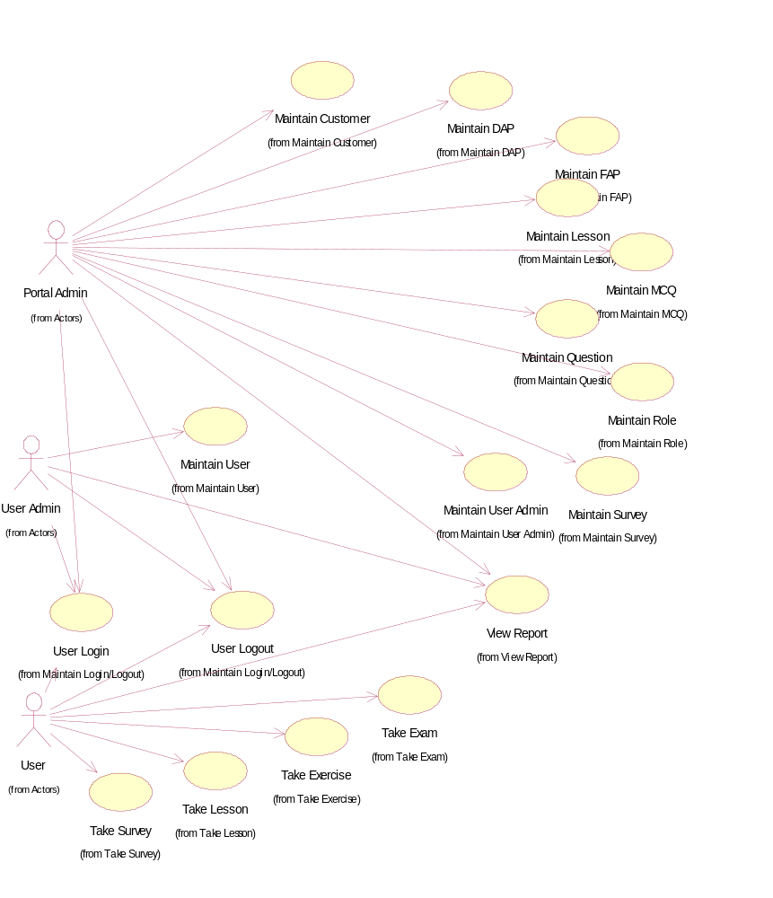
Use-Case Diagram: Global View of Actors and Use Cases

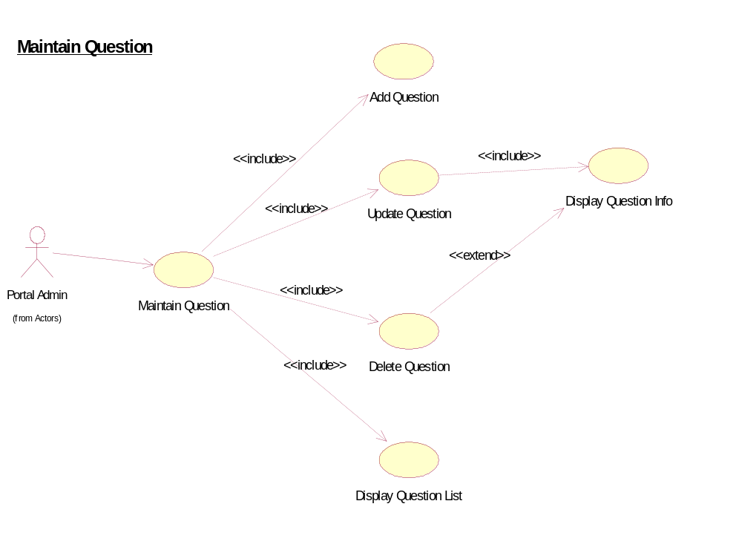
Use-Case Diagram: Maintain Question

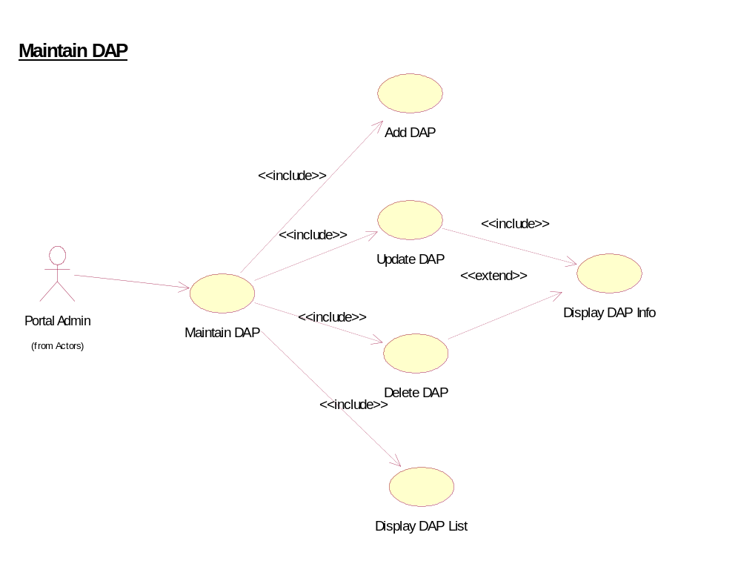
Use-Case Diagram: Maintain DAP

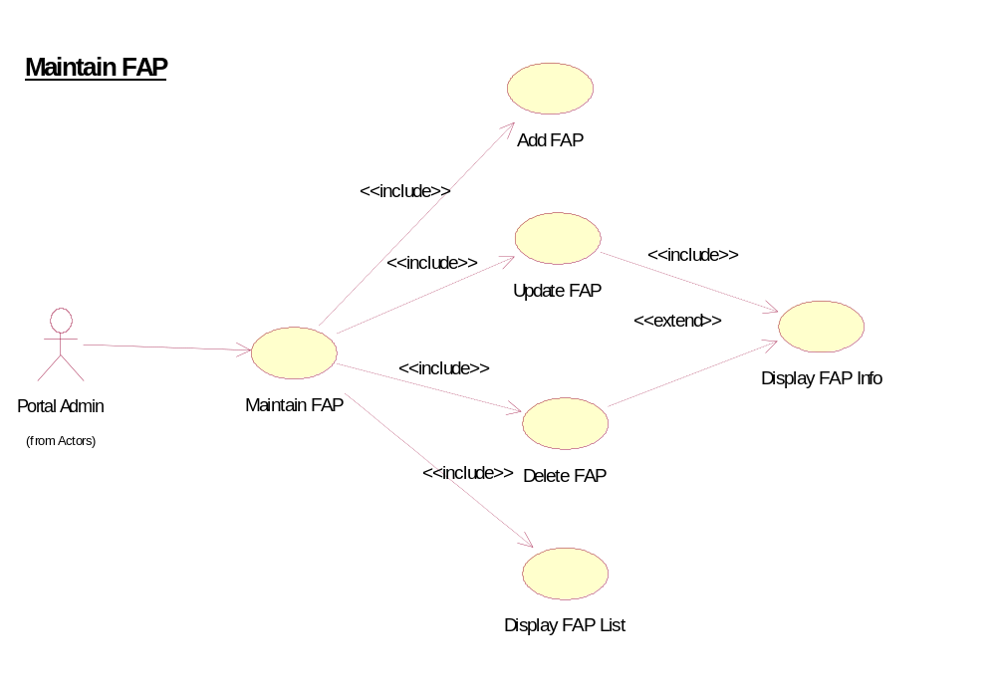
Use-Case Diagram: Maintain FAP

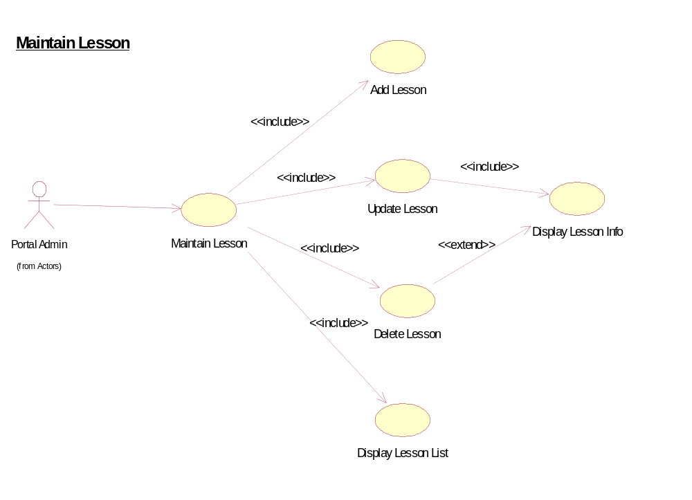
Use-Case Diagram: Maintain Lesson

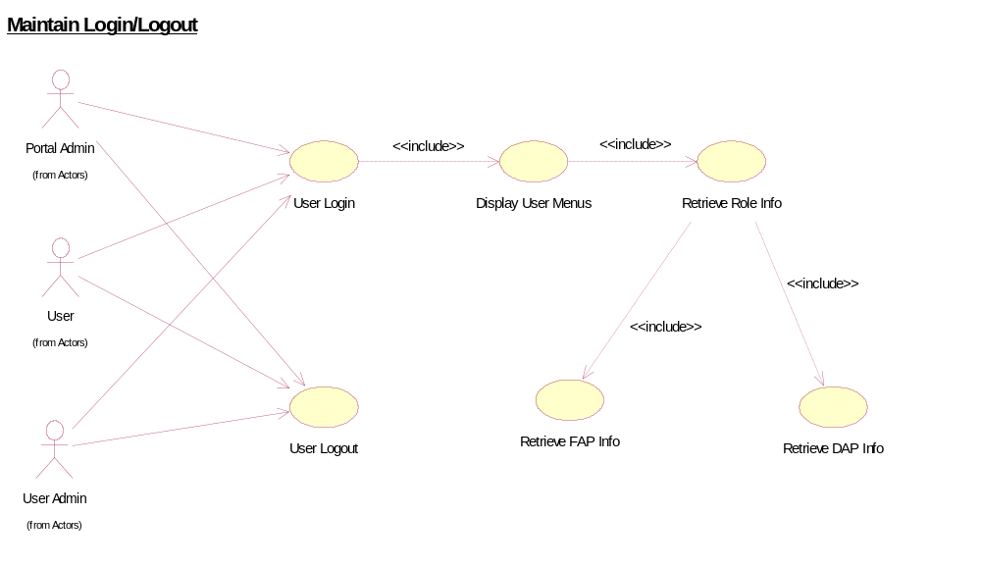
Use-Case Diagram: Maintain Login/Logout

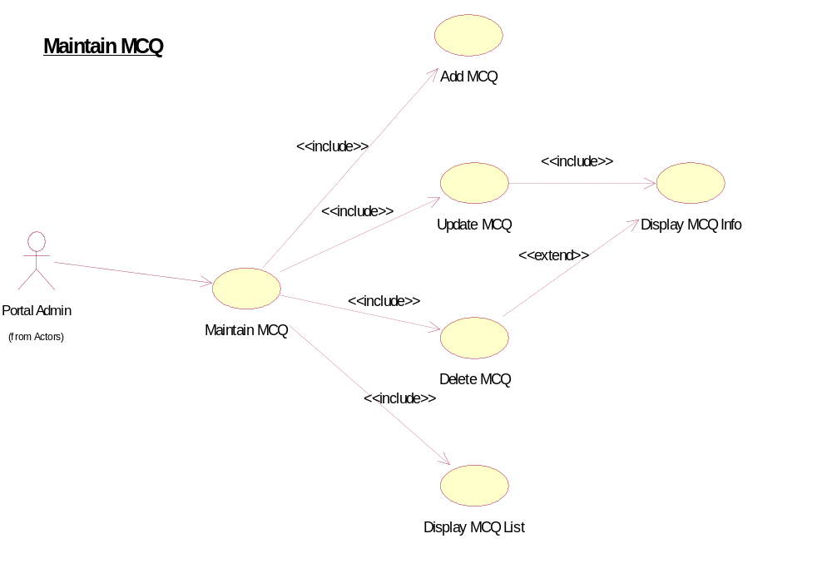
Use-Case Diagram: Maintain MCQ

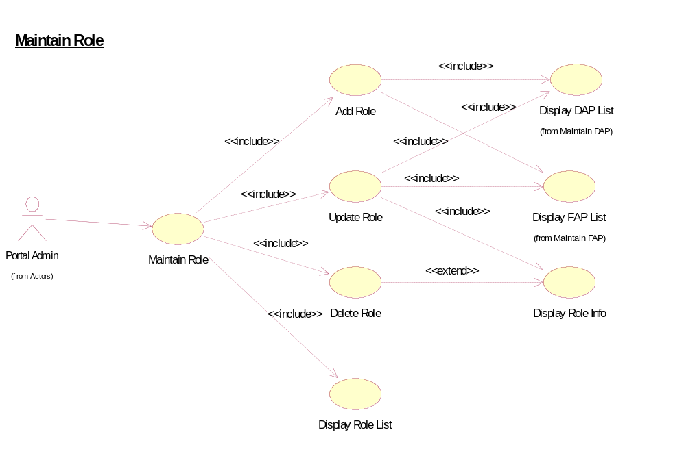
Use-Case Diagram: Maintain Role

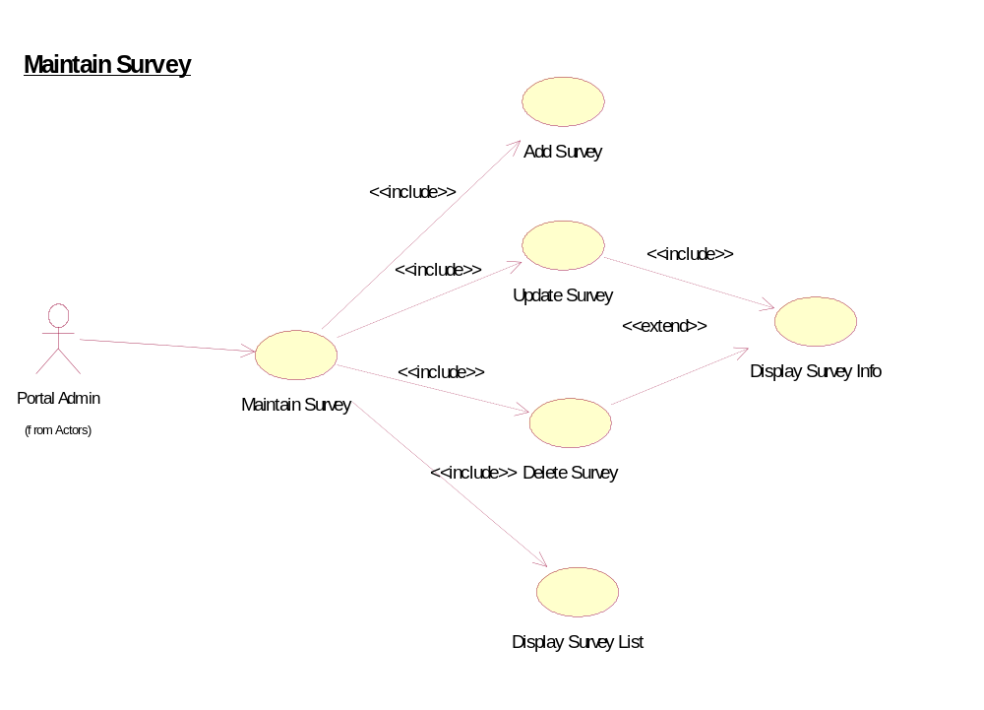
Use-Case Diagram: Maintain Survey

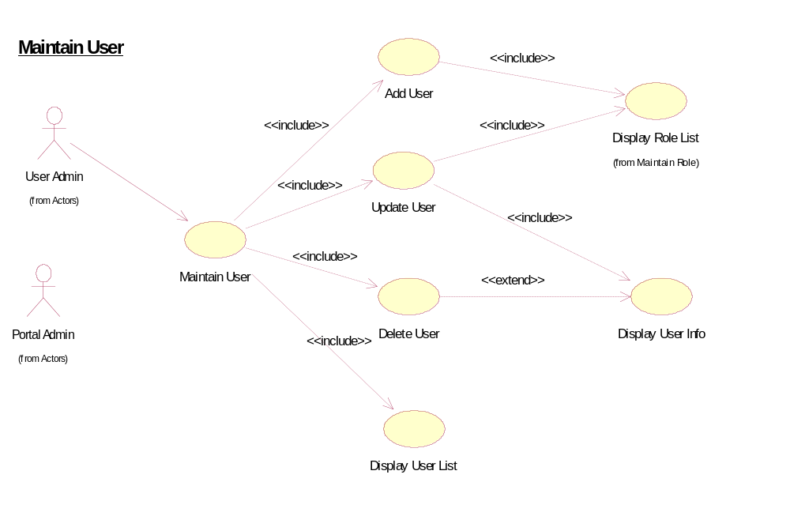
Use-Case Diagram: Mainain User

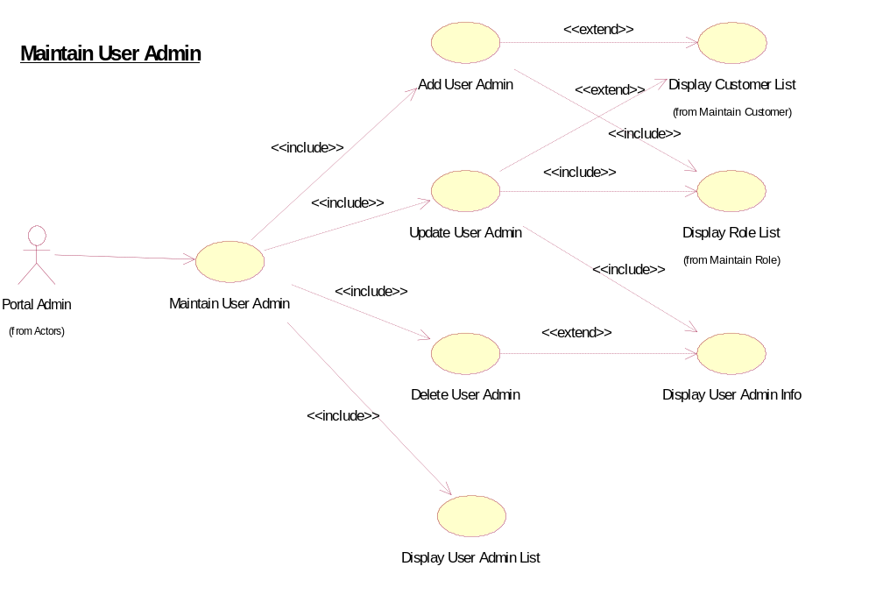
Use-Case Diagram: Maintain User Admin

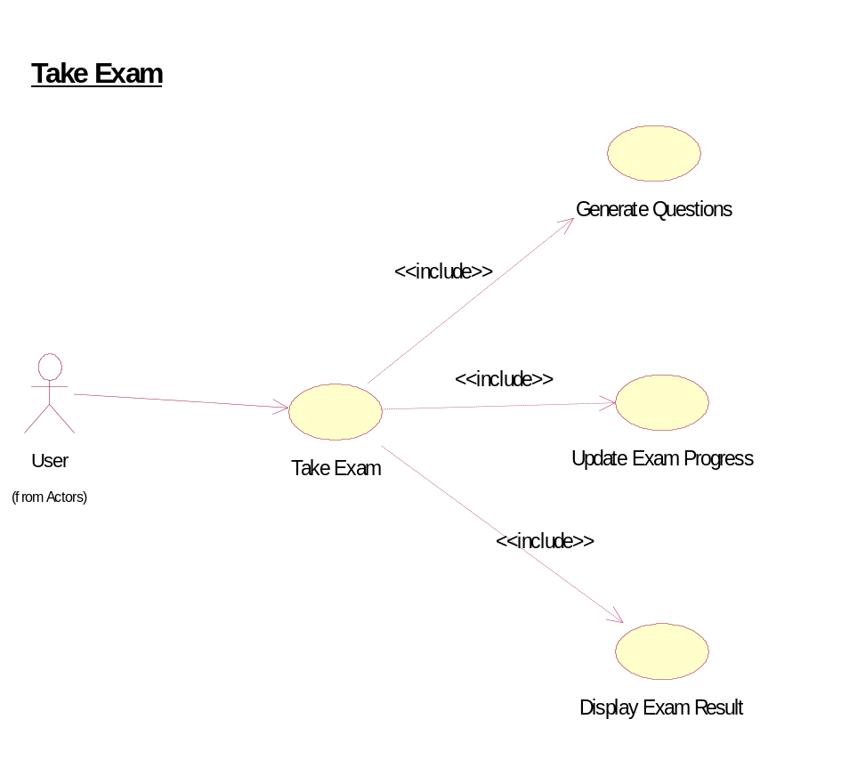
Use-Case Diagram: Take Exam

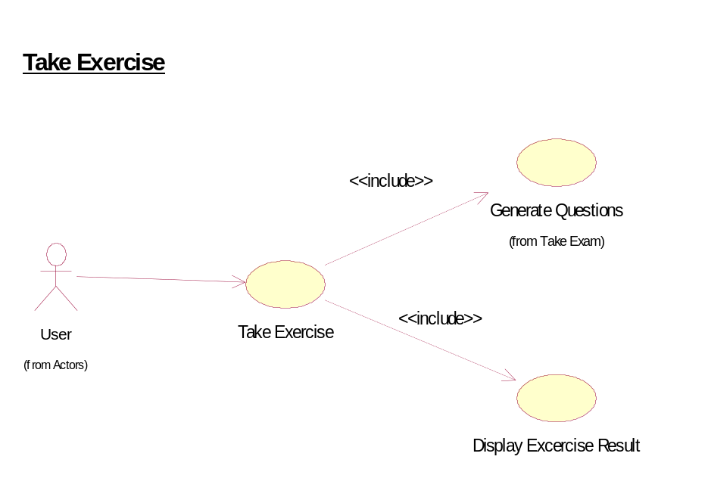
Use-Case Diagram: Take Exercise

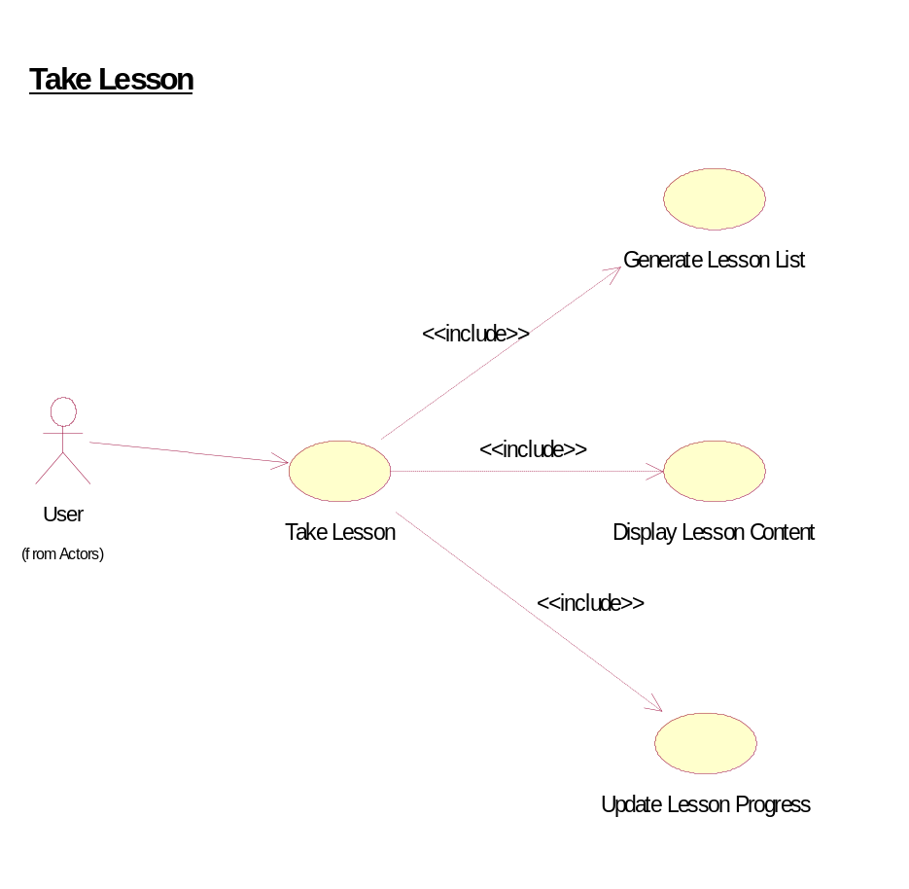
Use-Case Diagram: Take Lesson

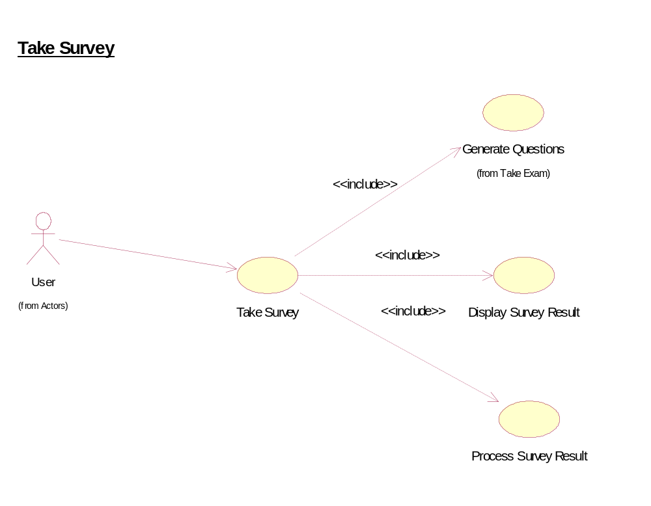
Use-Case Diagram: Take Survey

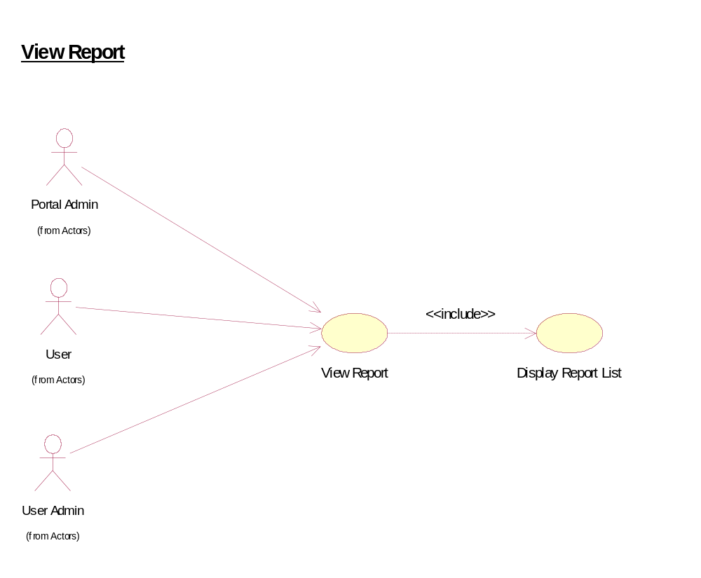
Use-Case Diagram: View Report

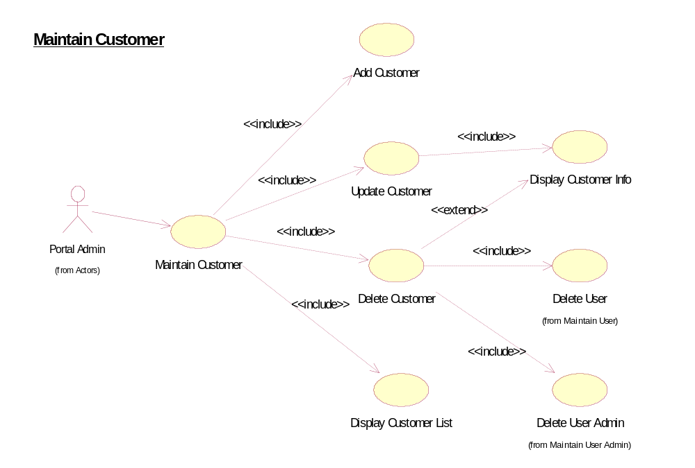
Use-Case Diagram: Maintain Customer

